1) Create VPC with 2 private and 2 public subnets.

2) Enable DNS Hostname in VPC

3) Enable Auto Assign Public ip in 2 public subnets

4) Add 2 private subnets in private route table

5) Add 2 public subnets in public route table

6) Public route table will have the routes to internet and local

7) Create Ec2 in public subnet with t2micro and install php

8) Configure Nat gateway in public subnet and connect to private Instance

9) Install Apache Tomcat in private ec2 and deploy a sample app.

10) Configure VPC flow logs and store the logs in s3 and CloudWatch.

1) Create VPC with 2 private and 2 public subnets.

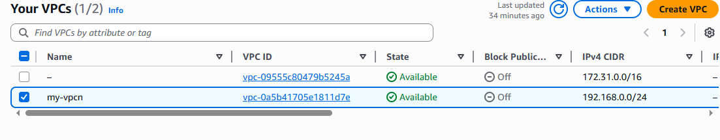

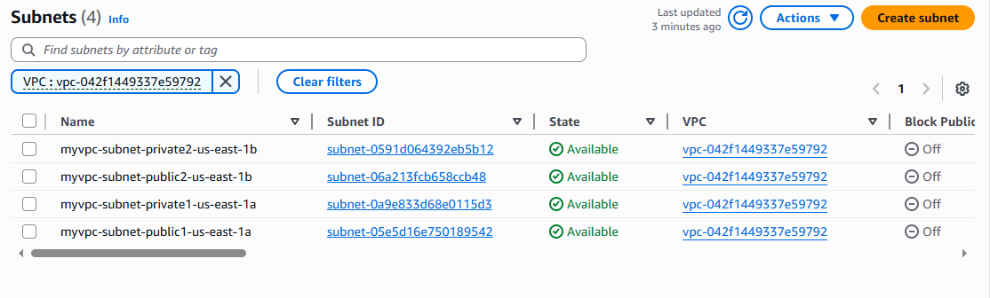

2) Enable DNS Hostname in VPC

**Why Enable DNS Hostnames?**

* It allows your EC2 instances in that VPC to get **public DNS names** (like ec2-3-85-23-111.compute-1.amazonaws.com).
* Useful when you access instances over the internet or resolve private DNS internally.

**DNS** stands for **Domain Name System**.

DNS is like the **phonebook of the internet**.

* You type a domain name like www.google.com
* DNS translates it into an IP address like 142.250.193.4 (which computers use to communicate)

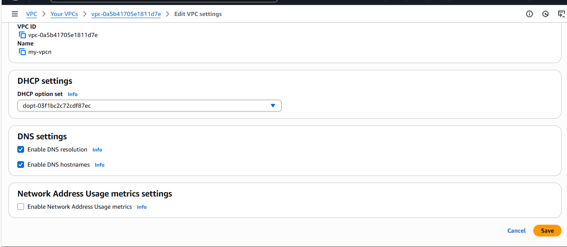

3) Enable Auto Assign Public ip in 2 public subnets

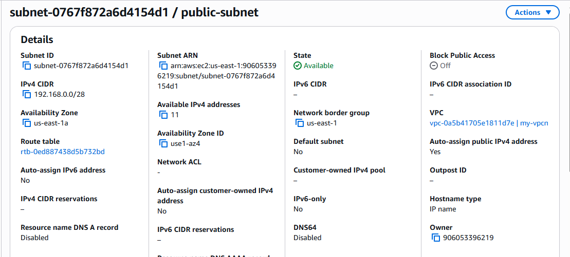

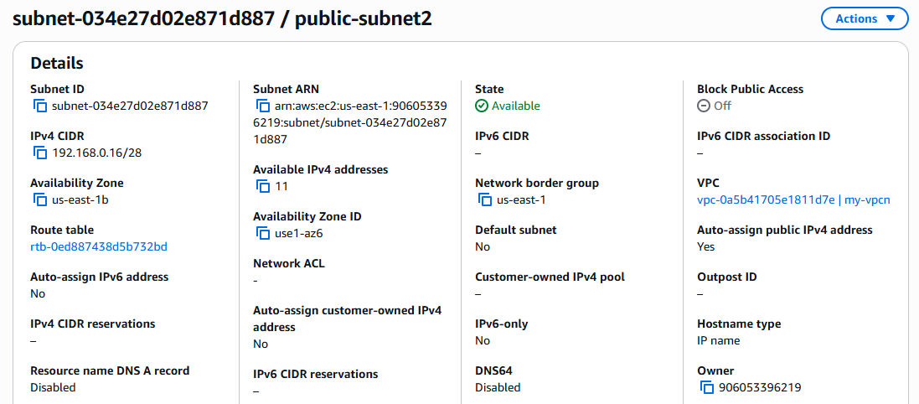

4) Add 2 private subnets in private route table

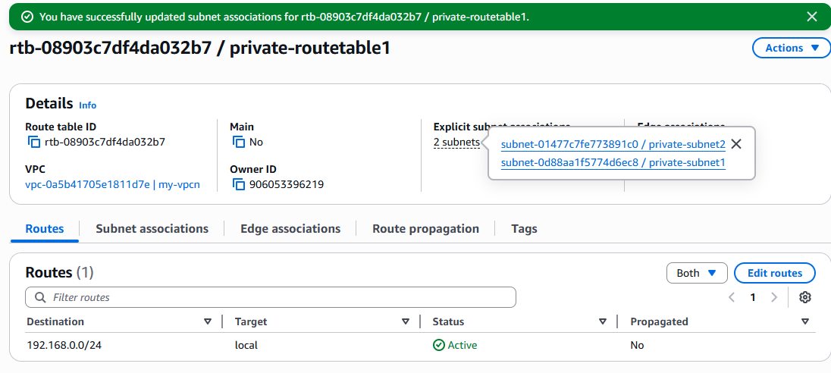

5) Add 2 public subnets in public route table

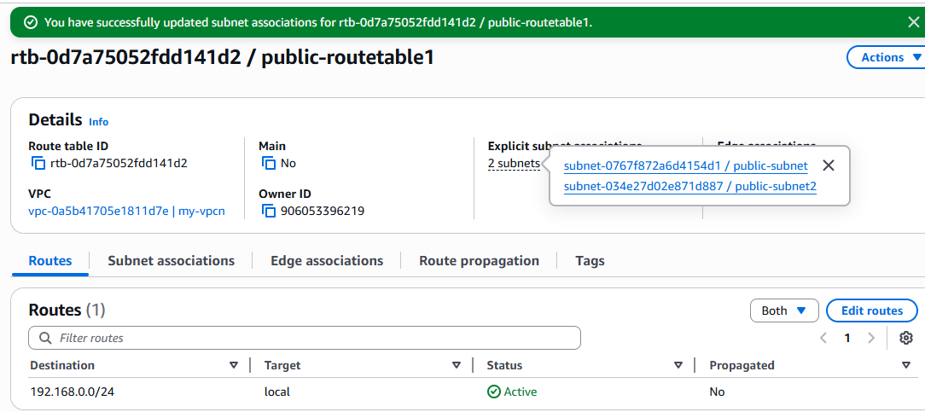

6) Public route table will have the routes to internet and local

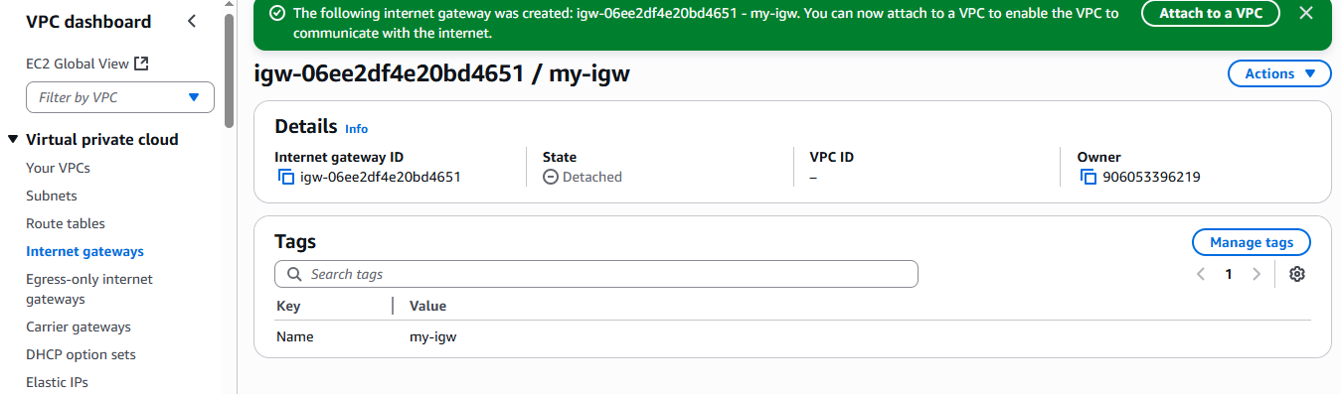

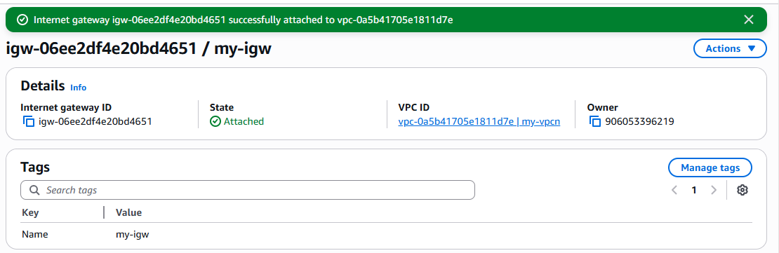

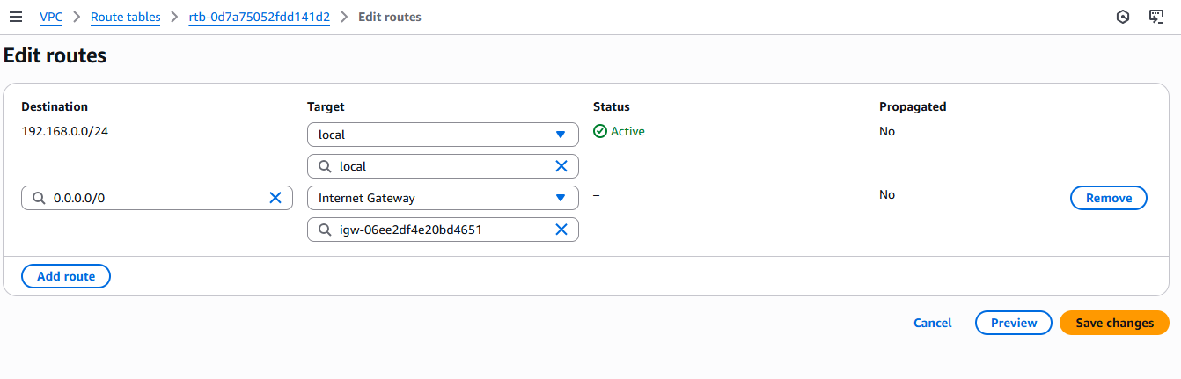

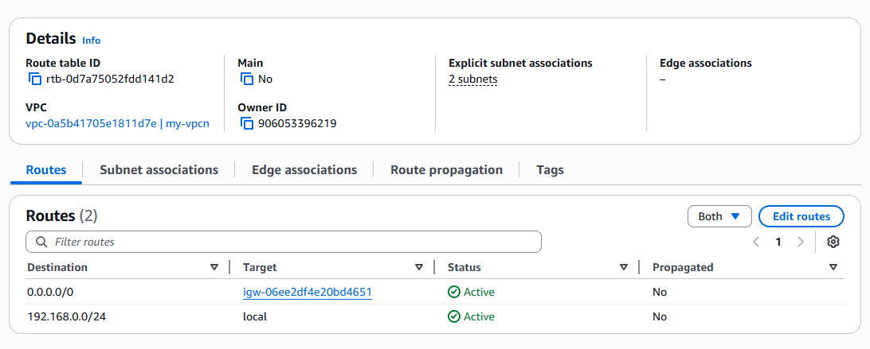

7) Create Ec2 in public subnet with t2micro and install php

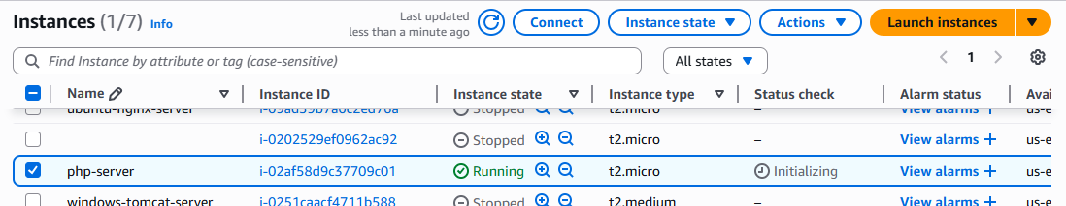

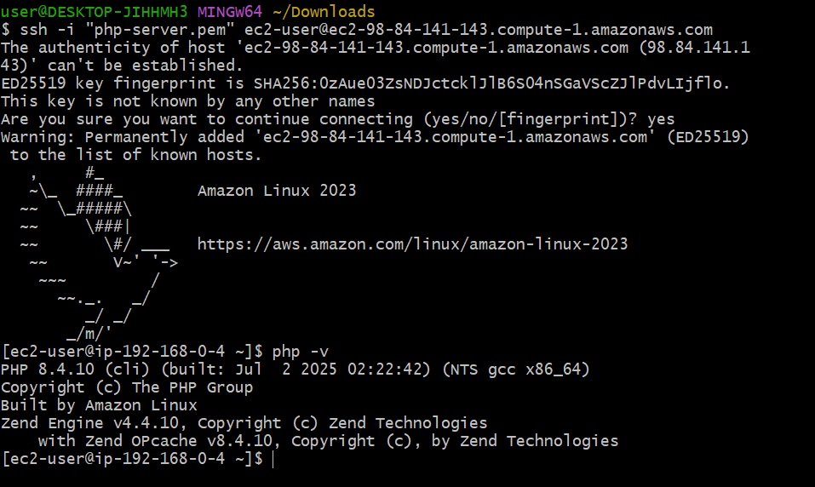

8 Question:

Configure Nat gateway in public subnet and connect to private Instance

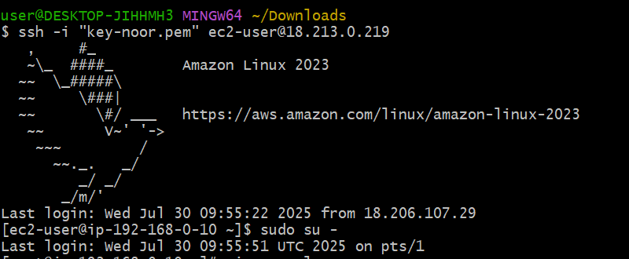

1. Connect ssh with public instance with public ssh ip
2. Then your observe ec2 user changed with your assigned IP (private IP4) of cidr of your publicsubnet.
3. Then change to root user sudo su –
4. Why changed tp root user because we want to see our internet is working or not on our assigned ip’s (private ip4)
5. Now check in root user internet is working or not with assigned IP
6. Ping google.com
7. Now internet is working for your public instance
8. Now check your private instance connecting ssh or not with it’s public IP4.
9. It showing it’s times out error and not connecting because we kept in private instance private subnet and aswell as we we didn’t give interent gateway access in private route table.
10. Ok now with out giving iGW access we want to access the internet for private subnet with it’s private instance. For this
11. Need to create private route table with assocaitation of private subnet and has rout of natgate way assigned (a gate which using other’s internet means from public instance.) for this

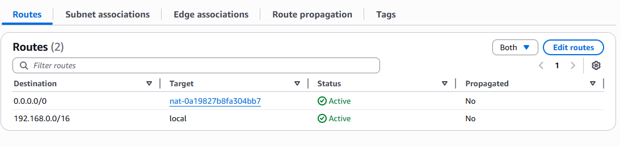

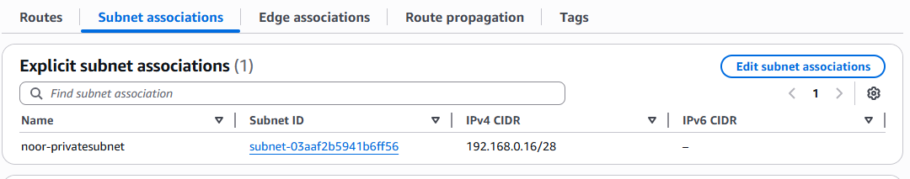

Just for analyse below

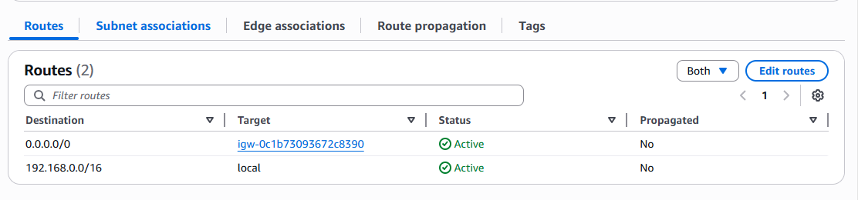

1. We should create NATgateway and assign with publicsubnet (means public instance)

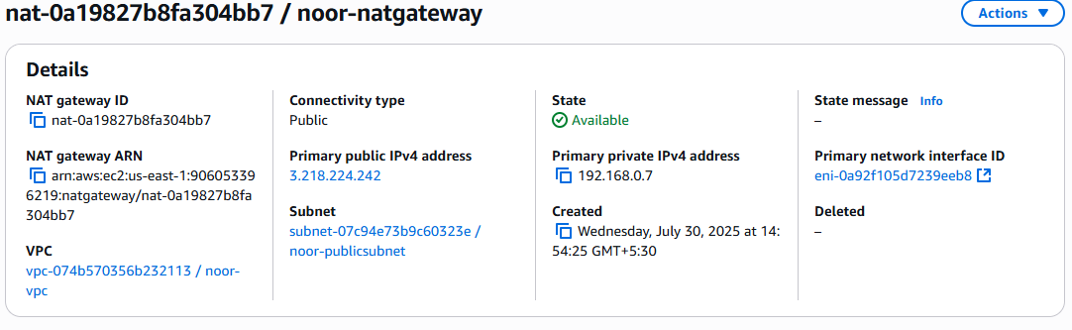

1. Now being in the rootuser of public instance ip , you just copy the pemkey file
2. Cat key-noor.pem
3. Copy it
4. Be there only and create one file and paste the pem key in this.
5. Vi textnoor.pem
6. Save it
7. Chmod 600 tectnoor.pem
8. Be in the same place
9. Now paste the command with textnoor.pem key and with private instance private IP



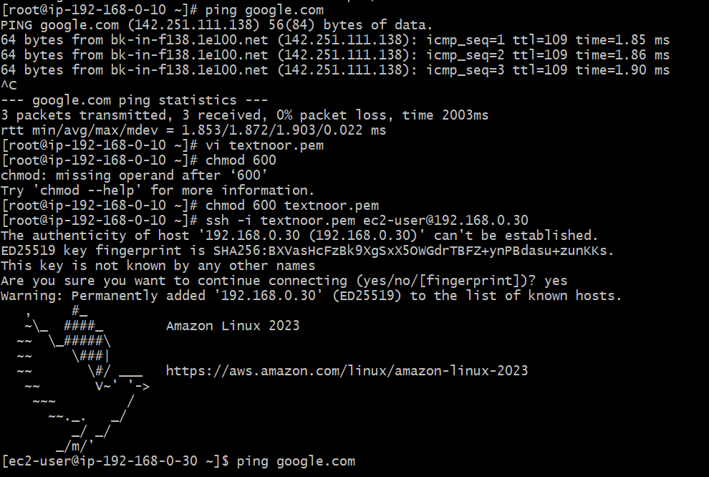

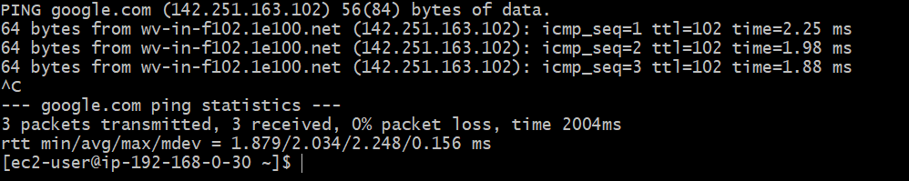

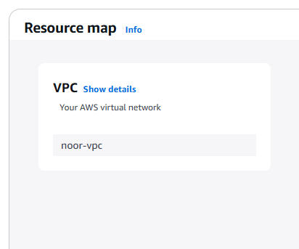

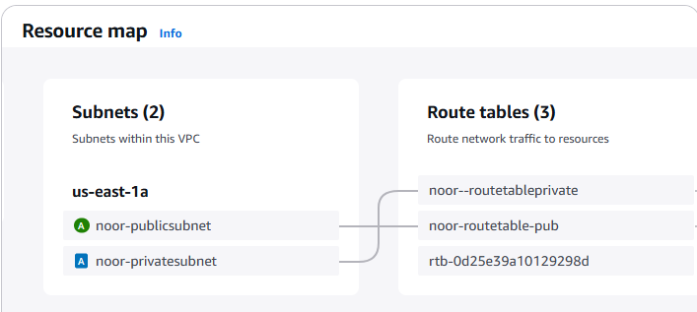

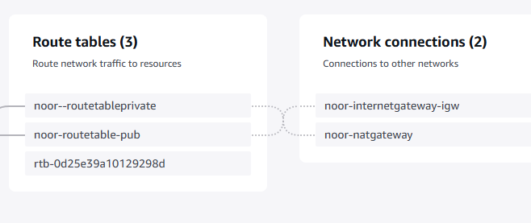

9) Install Apache Tomcat in private ec2 and deploy a sample app.

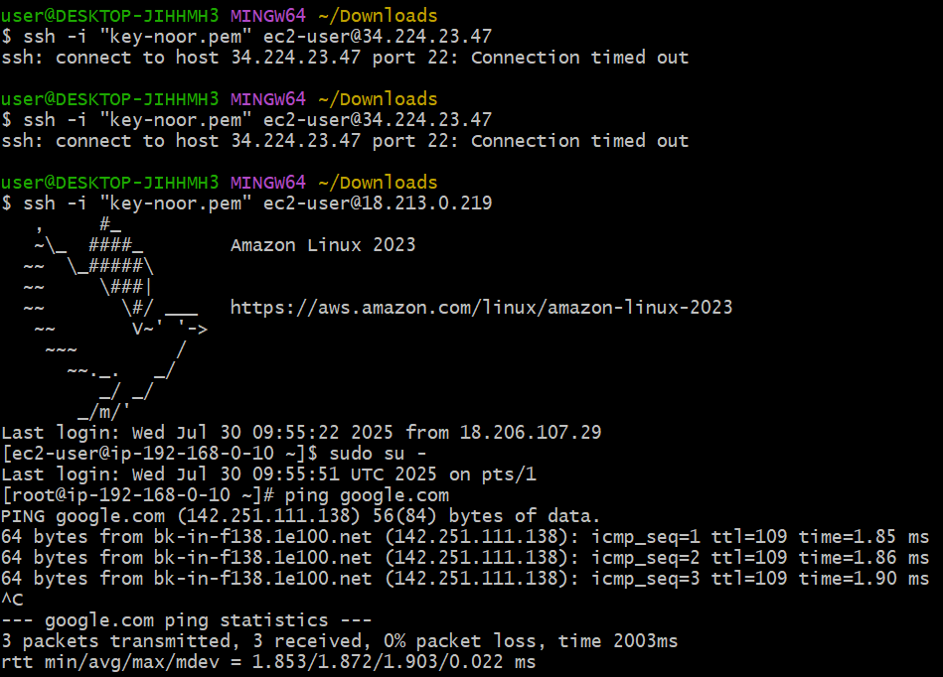

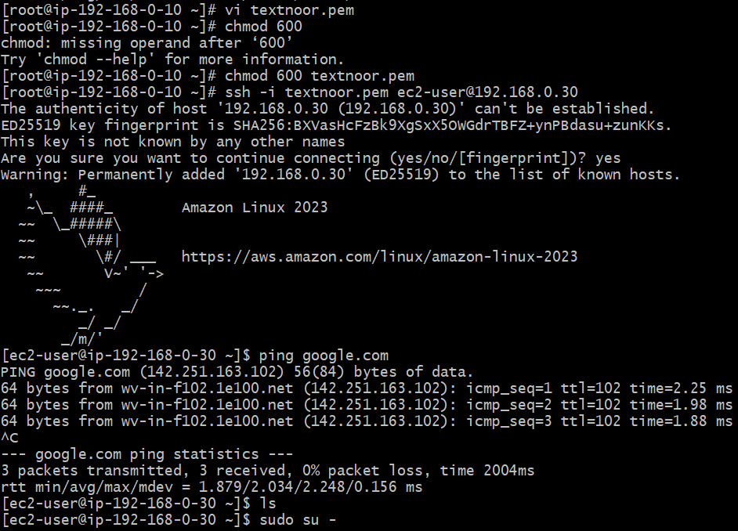 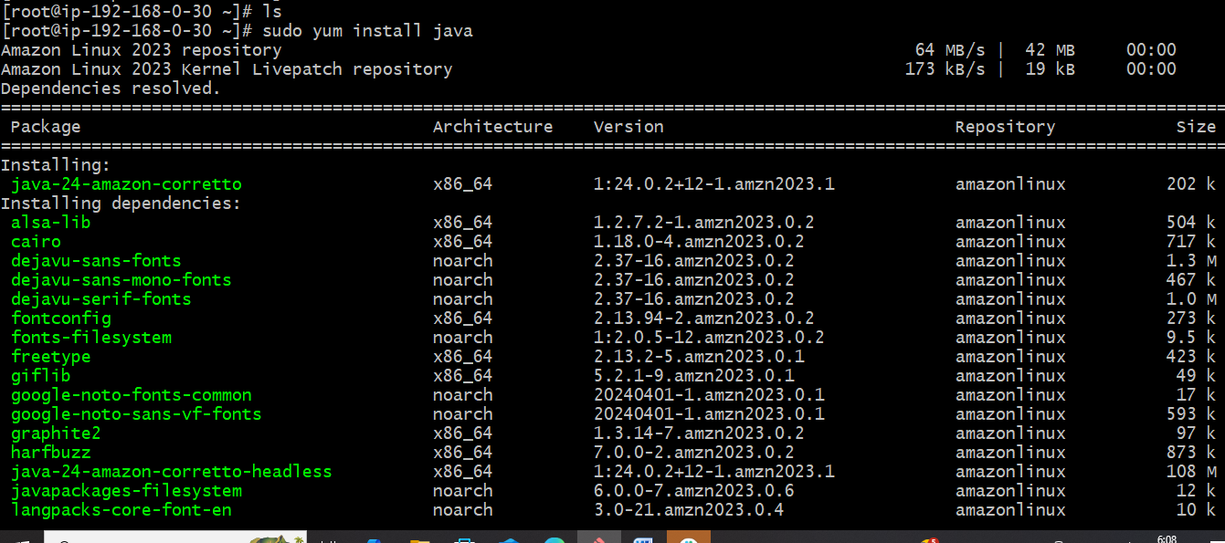

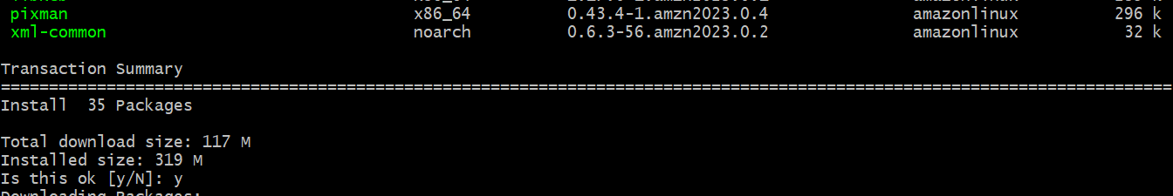

Press Y

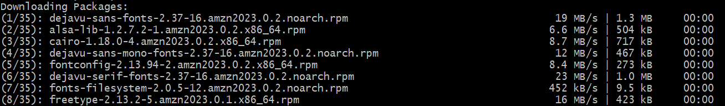

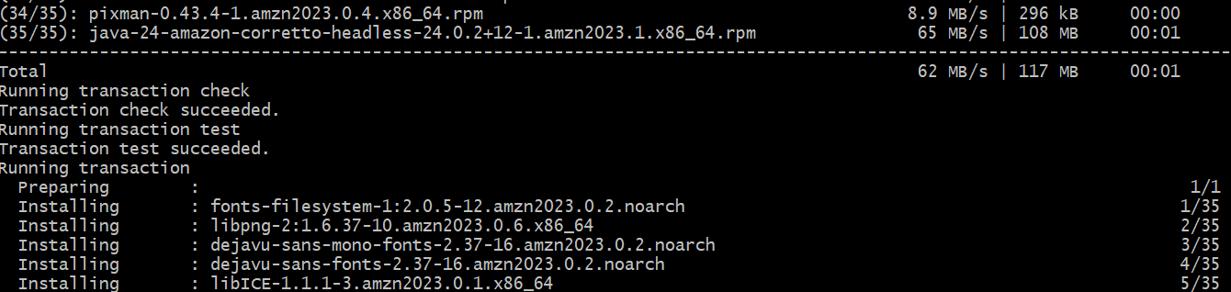

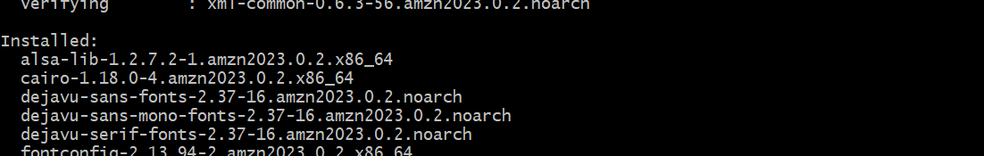

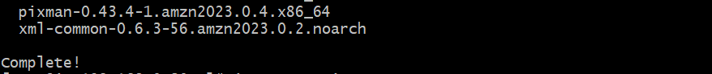

Check Java version

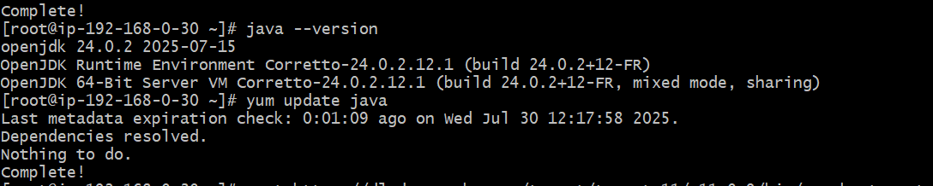

Then down load the apache tomcat from google

Enter in google search apache tomcat

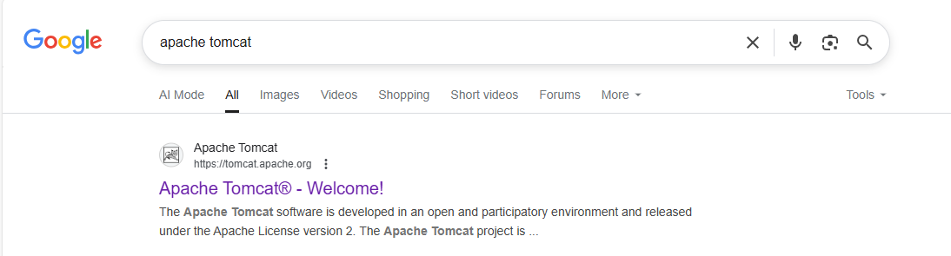

Got recent version let side that is 11

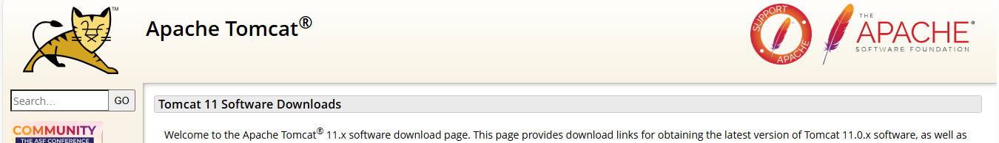

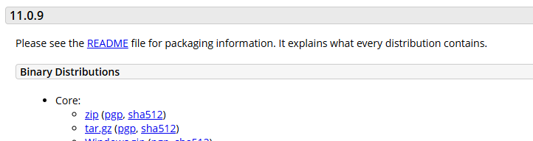

Copy the link of tar.gz (right click and copylink being on tar.gz)

And copy paste this link into the gitbashhere terminal along with command wget

Command

wget paste link here

and enter

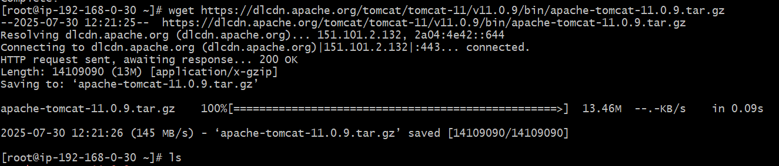

Just see the ls and ll

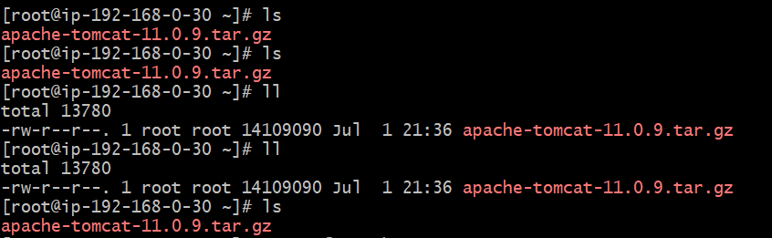

Then

Etract the tar file command is

Tar xvf filename

tar xvf apache-tomcat-11.0.9.tar.gz (in this case)



As below we need to go to dierent directories cd’s

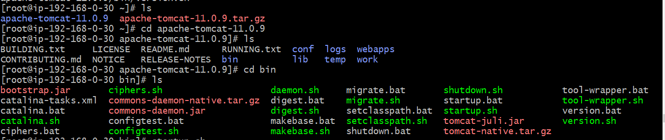

Start the tomcat

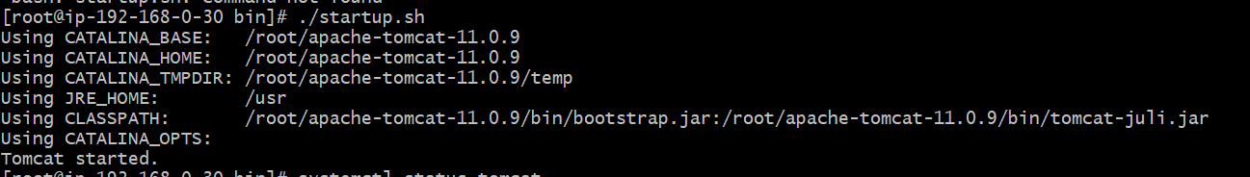

Now chek the default port of tomcat is running or not 8080



Run on local host

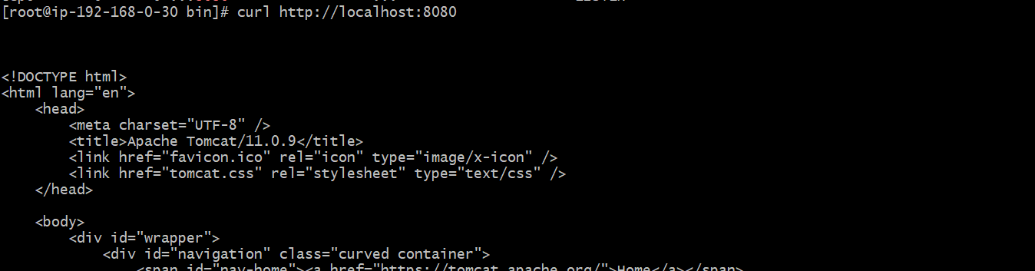 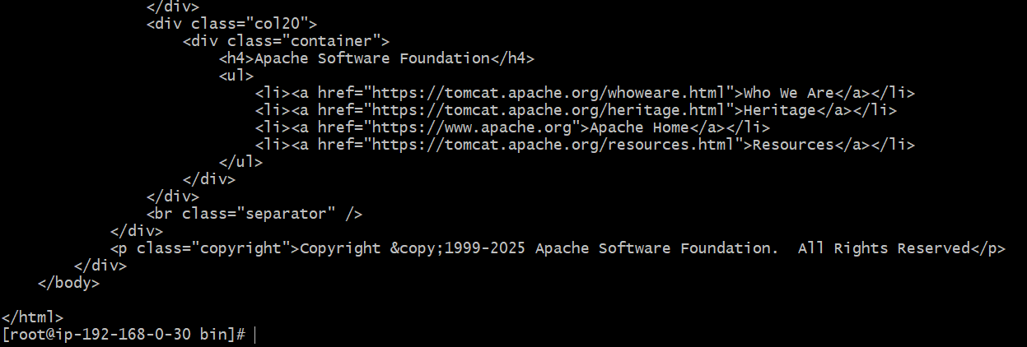

10) Configure VPC flow logs and store the logs in s3 and CloudWatch.

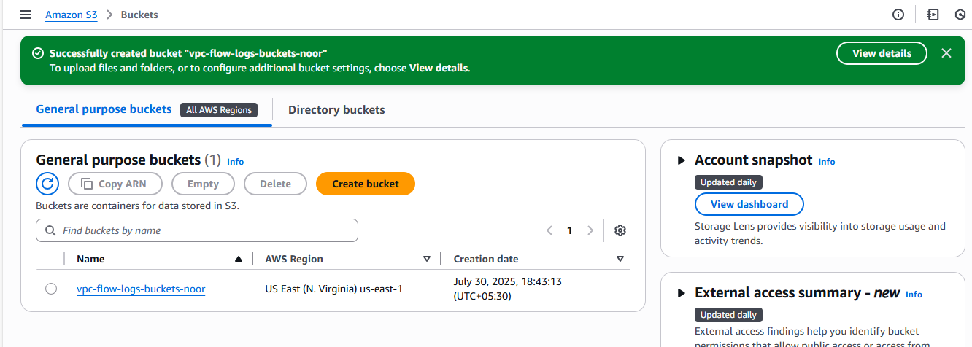

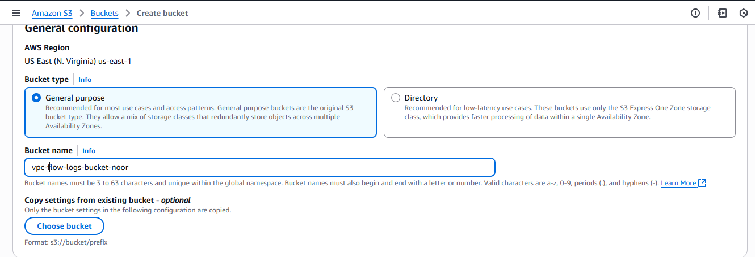

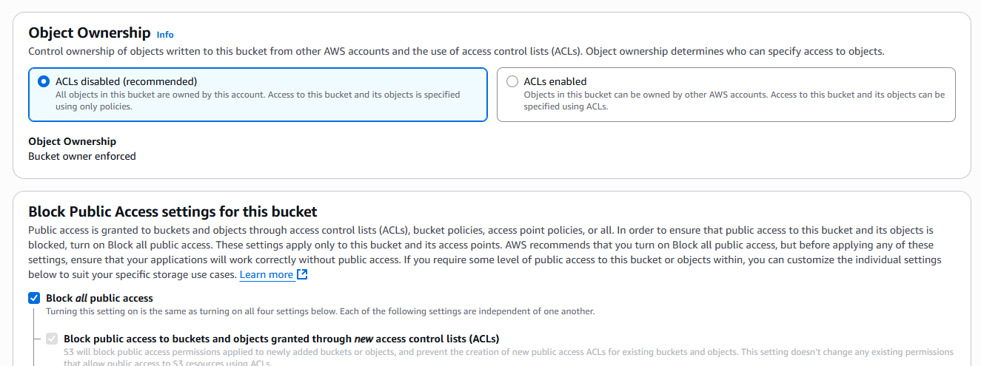

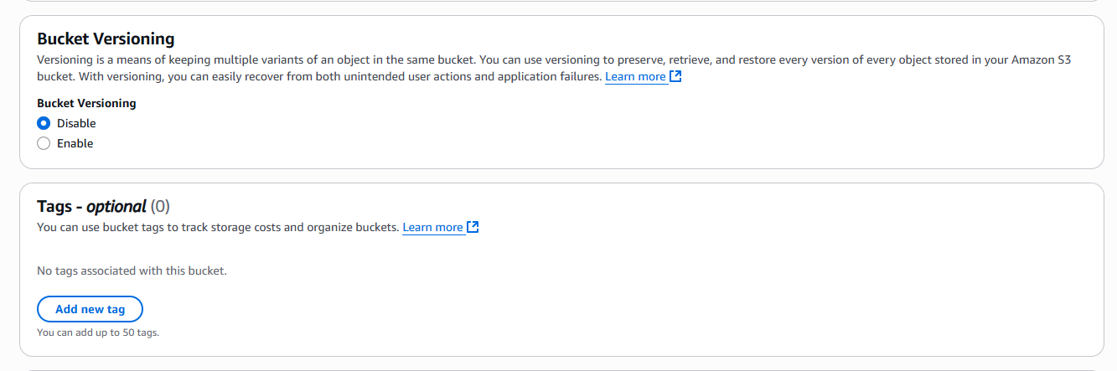

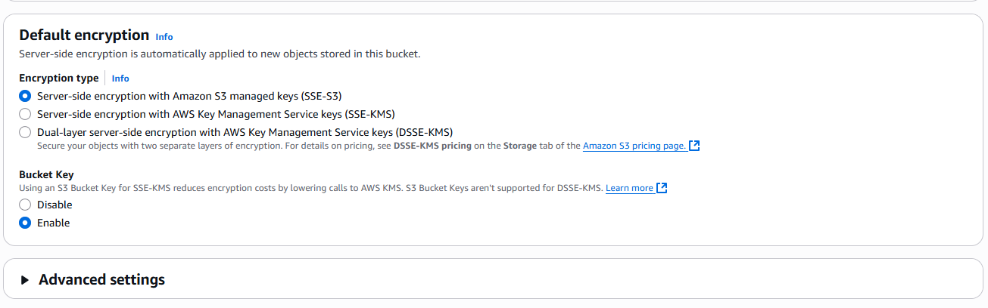

Go to VPC select your VPC

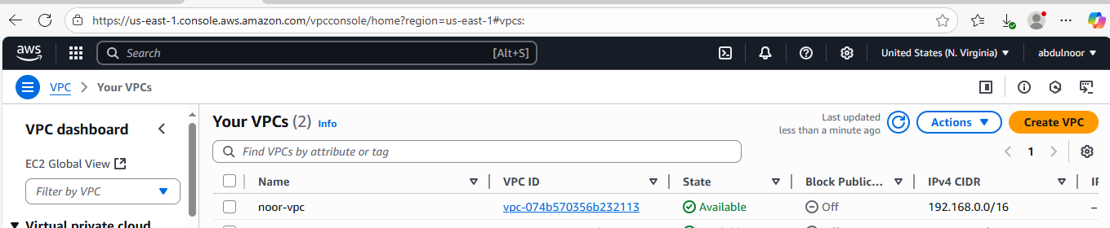

Click on create flow log

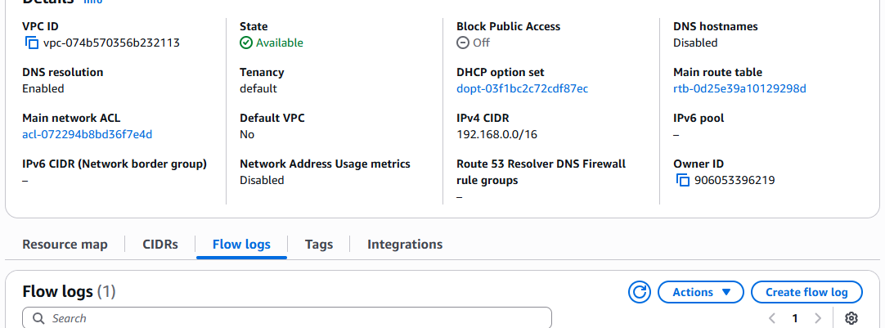

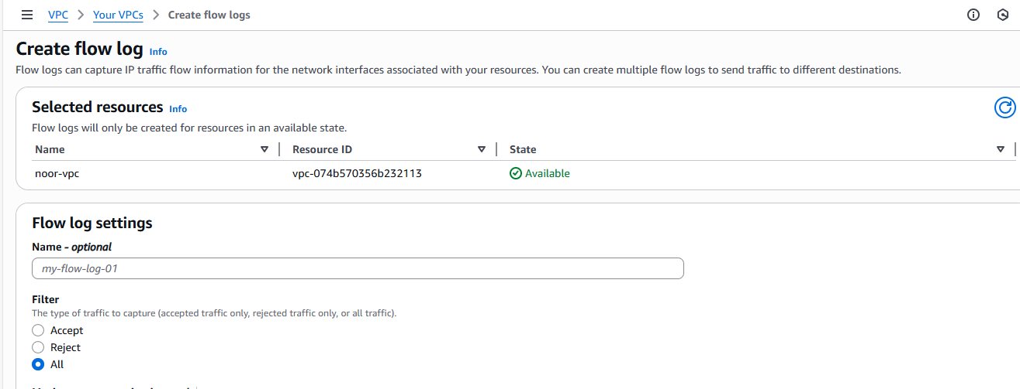

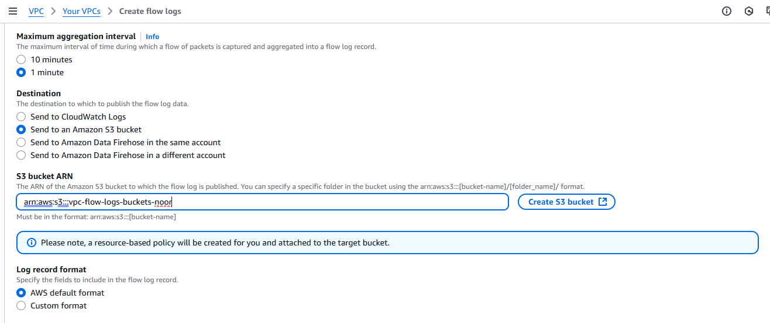

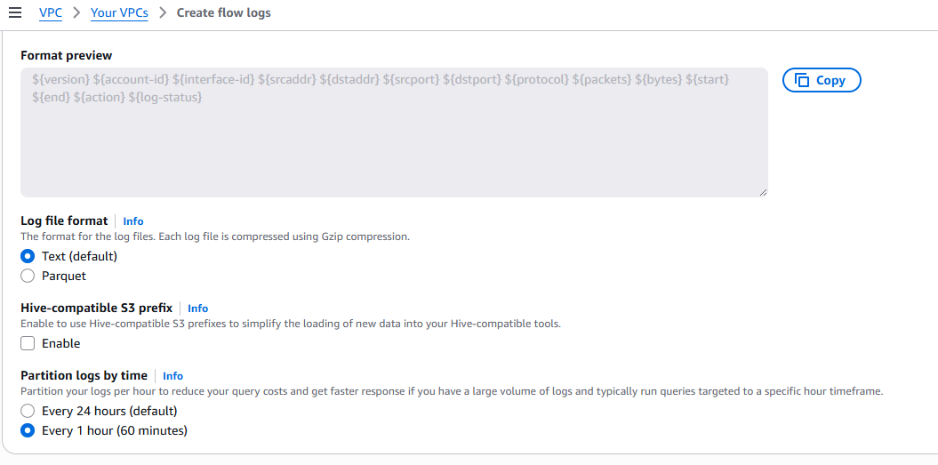

Click on create flow log

To see flow logs need go to VPC

Here your created flow log will appear and if you go inside inside etc., then it shows logs

